Module Application Intake

Introduction
This module creates a Word document containing the Application information from the input fields.
It can also export the Application information from the Registry.
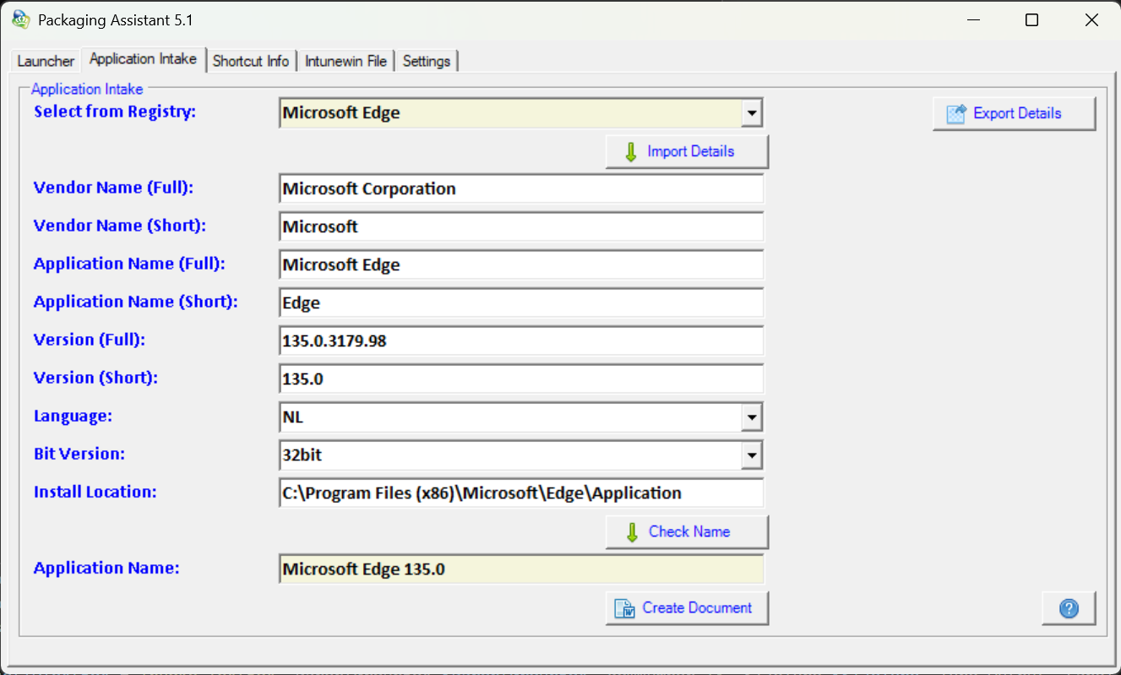

Instructions
Select an Application from the dropdown list labeled ‘Select from Registry’. (This list contains the names of the locally installed applications.)
Then click on ‘Import Details’. The Application information is now shown in the input fields.
Fill the fields ending with (Full) with the formal names of the Vendor/Application. These will be used to fill certain fields inside the Word document.
Fill the fields ending with (Short) with the shortened names of the Vendor/Application. These will be used to create the Asset ID.
Click ‘Check Name’.
The Application Name is now shown in the bottom field.

Click ‘Create Document’.
The Word document will be created and filled with the Application information.

To export the Application information to a text file, click ‘Export Details’.

